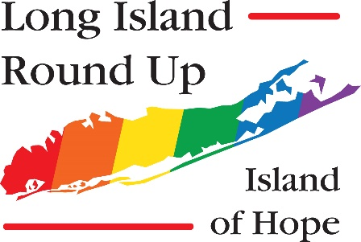
LONG ISLAND ROUNDUP REGISTRATION FORM
May 9, 2019 – May 12, 2019
Name:
Street Address:
City: | State: | Zip:
Phone: | Email:  Check if you would like to be added to our e-mail list
AA Recovery Date: | Al-Anon Serenity Date:
Name to Appear on Name Tag: | Additional Attendee(s) Name to Appear on Name Tag:
Would you like to chair a workshop? | Yes, I would like to chair an AA workshop  Yes  Yes, I would like to chair an Al-Anon workshop
ROUNDUP OPTIONS

Early Registration Postmarked by April 1, 2019 | Qty: | $50.00 | $
Registration Postmarked after April 1, 2019 | Qty: | $65.00 | $
Day Pass | Qty: | $25.00 | $
Scholarship | Please submit a completed registration with a letter from you and your sponsor stating the reason for your request. Scholarships are for registration fees only and may require a service commitment.
Scholarship Contribution | To assist those who otherwise may not attend |  | $
Hoodie (S,M,L,XL,XXL,XXXL) | Size:  Qty: | $25.00 | $
Friday Dinner | Qty: | $42.00 | $
Saturday Dinner | Qty: | $35.00 | $
Total: |  |  | $
Please mail this form and your check made payable to Long Island Roundup to:
The Long Island Roundup
PO Box 1423
West Babylon, NY 11704

